

Report ON AI Voice
Assistant using Python

Presented by: Abhijit Prakash
Roll No: RK21STB53
Registration No: 12110247
Section: K21ST
Course Code:INT404
Teacher’s Name: Dr. Rahul

ABSTRACT
As we all know now, we are living in the era of computers. We all would have wondered how convenient it would be if we had our own virtual AI assistant (just like J.A.R.V.I.S), imagine how easier and effortless it would be to send emails without typing a single word, searching on Wikipedia without actually opening the web browsers, and performing many other daily tasks with the help of a single voice command. As of today, voice assistants are now everywhere. Voice based artificial Intelligence is here to play an important role in our daily life. Several such applications include Siri on Apple devices, Cortana on Microsoft Devices, and Google Assistant on Android devices. There are also devices dedicated to providing virtual assistance. The technologies that power virtual assistants require massive amounts of data, which feeds artificial intelligence (Al) platforms, including machine learning, natural language processing and speech recognition platforms. No matter where is voice assistant's future at, at the end of the day, it will be at a place that can assist human and benefits us.
Virtual assistants are typically cloud-based programs that require internet-connected. devices and/or applications to work. As the end user interacts with a virtual assistant, the Al programming uses sophisticated algorithms to learn from data input and become better at predicting the end user's needs. Virtual assistants typically perform simple jobs for end users, such as adding tasks to a calendar, providing information that would normally be searched in a web browser, or a little more complex tasks like checking the status of smart home devices etc. The work is initialized by analysing the audio commands given by the user via microphone. The speech engine is setup up so that it can convert the text to speech using inbuild libraries. Speech recognition is used to convert the speech input to text. This text is then fed to the model which determines the nature of the command and calls the relatable script for execution. This is basically what happens when the assistant receives a command from the user.

Table of content
Abstract
List of Figures
Introduction
Problem Definition!
Software Requirements Specification
System Design
Implementation
Results and Discussion

List of Figures

Figure 4.2.1 System design flow chart
Figure 6.1 shows the result when asked for date, day and time
Figure 6.2 shows the result when asked to open a YouTube video about
education.
Figure 6.3 shows a page from Wikipedia about photosynthesis
Figure 6.4 shows the output when a command "open python.org
is provided to assistant.
Figure 6.5 here we are demonstrating the output when we ask the assistant to tell about Prime Minister of India.

Chapter 1 Introduction
We are now living in the age of technology. Most of our day-to-day activities are made a lot more convenient and effortless with the help of new technology and computer-controlled devices. Technology is developing day by day and more and more software and systems are developed to help humans in any way possible. "Hi, Google, how is the weather?", "Alexa, where is the closest post office?" These questions had been adapted to our daily life. Voice-based artificial intelligence is here to play an important role in our daily life. The application of voice assistants is growing fast in our personal and professional life.

Voice assistants are devices/apps that use voice recognition technology, natural language processing, and Al to respond to humans. Using the technology, the device synthesizes the user's message, breaks it down, evaluates it, and offers a meaningful response in return. Famous applications like Amazon Alexa, Apple Siri and Google Assistant are typically cloud-based for maximum performance and data management. Many behavioural traces, including the user's voice activity history with extensive descriptions, can be saved in a voice assistants ecosystem's remote cloud servers during this process. The first tool that becomes digital speech recognition was IBM's shoebox, it was released to the public in the year of 1'62, and it could only understand 16 English words (Clark, 2018). The next development in voice recognition technology came in the 1970s from Carnegie Mellon University in Pennsylvania with the aid of the United States Department of Defence. That tool is named 'Harpy': it can understand about 1100 English words. After 10 years, A system that not only analysed individual words but also entirely word sequence has been developed by the same group of scientists. In the 1990s, digital speech recognition was a new feature of the personal computer. The launch of the first smartphone the IBM 'Simon' in 1994 laid a foundation for the smart virtual assistant as we have known of today, Siri and Google home voice assistant were brought to the public in 2018-2011. As of today, voice assistants are now everywhere. The concept of artificial intelligence, natural language processing and machine learning are applied to develop this system.
Chapter 2
Problem Definition
2.1 Objectives
- The main objective is building a virtual assistant is using data sources available on the web, user-generated content and providing knowledge from knowledge databases.

- On the desktop platform, the intelligent voice assistant can be used to carry out tasks. Through commands which otherwise require input devices. We are trying to reduce the effort and time required to perform certain tasks.

- This will enable the voice assistant to recognize audio input from the user, interpret the command and then perform the task requested by the user or respond appropriately.

2.2 Problem Definition

Al voice assistants are here to stay and grow. More and more systems are being developed by people around the world. We already have multiple vice assistants. But we hardly use them. There are a number of people who have issues with voice recognition. These systems can understand English phrases but they also fail to recognize our accent. Our way of pronunciation is way distinct from theirs. Also, they are easy to use on mobile devices rather than desktop systems. There is a need for a voice assistant that can understand English in Indian accent and work on desktop systems.

Chapter 3
Software Requirements Specification

The system is built keeping in mind the generally available hardware and software compatibility, it doesn't require any expensive hardware devices. The minimum hardware and software requirements for the system are listed below.

3.1 Hardware Requirement:

- Processor-minimum Intel(R) Core (TM) i5-11500U CPU @ 2.20GHz 2.60 GHz

- Processor speed- minimum 2 GHz

- RAM- Minimum of 2GB

3.2 Software Requirement:

- pyttsx3 - is a text-to-speech conversion library in Python. Unlike alternative libraries, it works offline, and is compatible with both Python 2 and 3. An application invokes the pyttsx3.init() factory function to get a reference to a pyttsx3. Engine instance. It is a very easy-to-use tool that converts the entered text into speech. The pyttsx3 module supports two voices first is female and the second is male which is provided by "sapi" for windows. It supports three TTS engines: sapi5- SAPIS on Windows, nsss- NSSpeechSynthesizer on Mac OS X, espeak-eSpeak on every other platform.

- Speech Recognition - to allow us to convert audio into text for further processing. The speech recognition module is used to covert the audio into text. We are also using the Google web speech API and turn the spoken language into text using recognize_google ().

- Visual studio code - Visual Studio Code is a streamlined code editor with support for development operations like debugging, task running, and version control. It aims to provide just the tools a developer needs for a quick code-build-debug cycle and leaves more complex workflows to fuller featured IDES, such as Visual Studio IDE. It is a source code editor made by Microsoft for Windows, Linux and macOS. Features include support for debugging, syntax highlighting, intelligent code completion, snippets, code refactoring, and embedded Git. Users can change the theme, keyboard shortcuts, preferences, and install extensions that add additional functionality.

Chapter 4
System Design

4.1 Stages:
Step 1: Start

Step 2: Once the system is switched on it then has to wait for input from the user. In this stage, the system will be trying to listen for various user inputs.

Step 3: The received audio input is converted to text so that it can be processed further.
Step 4: The input is analysed further so that the system can decide if it's a query/question or a command to perform some tasks.
Step 5: If the input is classified as a question/query then an appropriate response is generated

Step 6: If the input is classified as a command to perform a task, then the command is executed to perform the requested task.

Step 7: Convert the response(text) into audio that can be presented as the output.

Step 8: Once the requested task is performed the output is displayed to the user.
Step": When "bye" is received as input from the user the system stops running.

4.2 Flow Diagram:
START

WAIT FOR AUDIO INPUT

CONVERT AUDIO TO TEXT

GENERATE APPROPRIATE RESPONSE
IS INPUT A QUESTION?
ANALYSE THE INPUT

EXECUTE THE COMMAND

DISPLAY THE OUTPUT
CONVERT TEXT TO AUDIO OUTPUT

STOP
“BYE”

Chapter 5
Implementation

Step 1: Setting up the speech engine
The pyttsx3 module is stored in a variable name engine. pyttsx3 is a text-to-speech conversion library in Python. Unlike alternative libraries, it works offline and is compatible with both Python 2 and 3. It is a very easy-to-use tool that converts the entered text into speech. The pyttsx3 module supports two voices first is female and the second is male.

Step 2: Speech Recognition
Speech recognition is a machine's ability to listen to spoken words and identify them. Speech recognition allows us to convert audio into text for further processing. The speech recognition module is used to convert the audio into text. It can be used to convert the spoken words into text, make a query or give reply. We are creating an instance of the Recognizer class and we will use recognize_google() method on it to access the Google Web Speech API and turn spoken language to text.

Step 3: Neural network for assistant
Neural networks comprise of layers/modules that perform operations on data. The torch. nn namespace provides all the building blocks you need to build your own neural network and define our neural network. Then create the neurons through which data and computations flow. The input comes from the raw data set We use NumPy to build a single neuron. NLTK is a toolkit built for working with NLP in Python. It provides us with various text processing libraries with a lot of test datasets. A neural network is a series of algorithms that endeavors to recognize underlying relationships in a set of data through a process that mimics the way the human brain operates. They develop the output without programmed rules.

Step 4: Categorizing
We are generating the probability where we train the model what to respond like if we are communicating with the assistant the assistant should be able to categorize the conversation under the specific tag using the probability.

Step 5: Tasks
There are two types of inputs: input function and non-input function. Examples of non-input function are Time, Date etc. and examples of input functions - google search, Wikipedia etc. Such tasks can be implemented using various modules provided by python like datetime, Wikipedia, pywhatkit etc. We can also provide tasks for interacting with operating system using OS library. And based on the tasks we add, we even need to add various tags related to the task which can make the conversation better after training the model.

Chapter 6
Result and Discussions

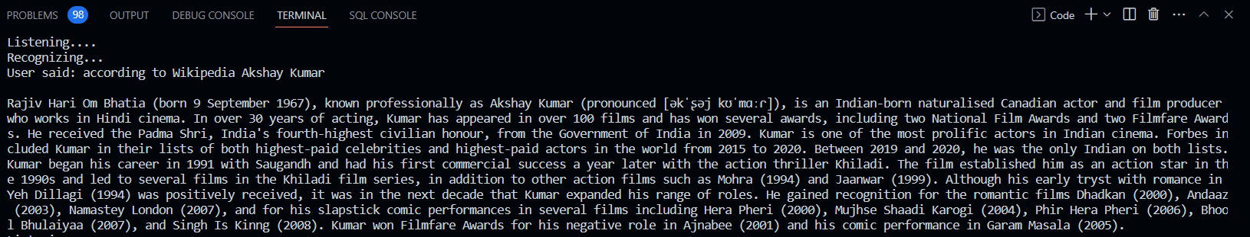

Opening Youtube
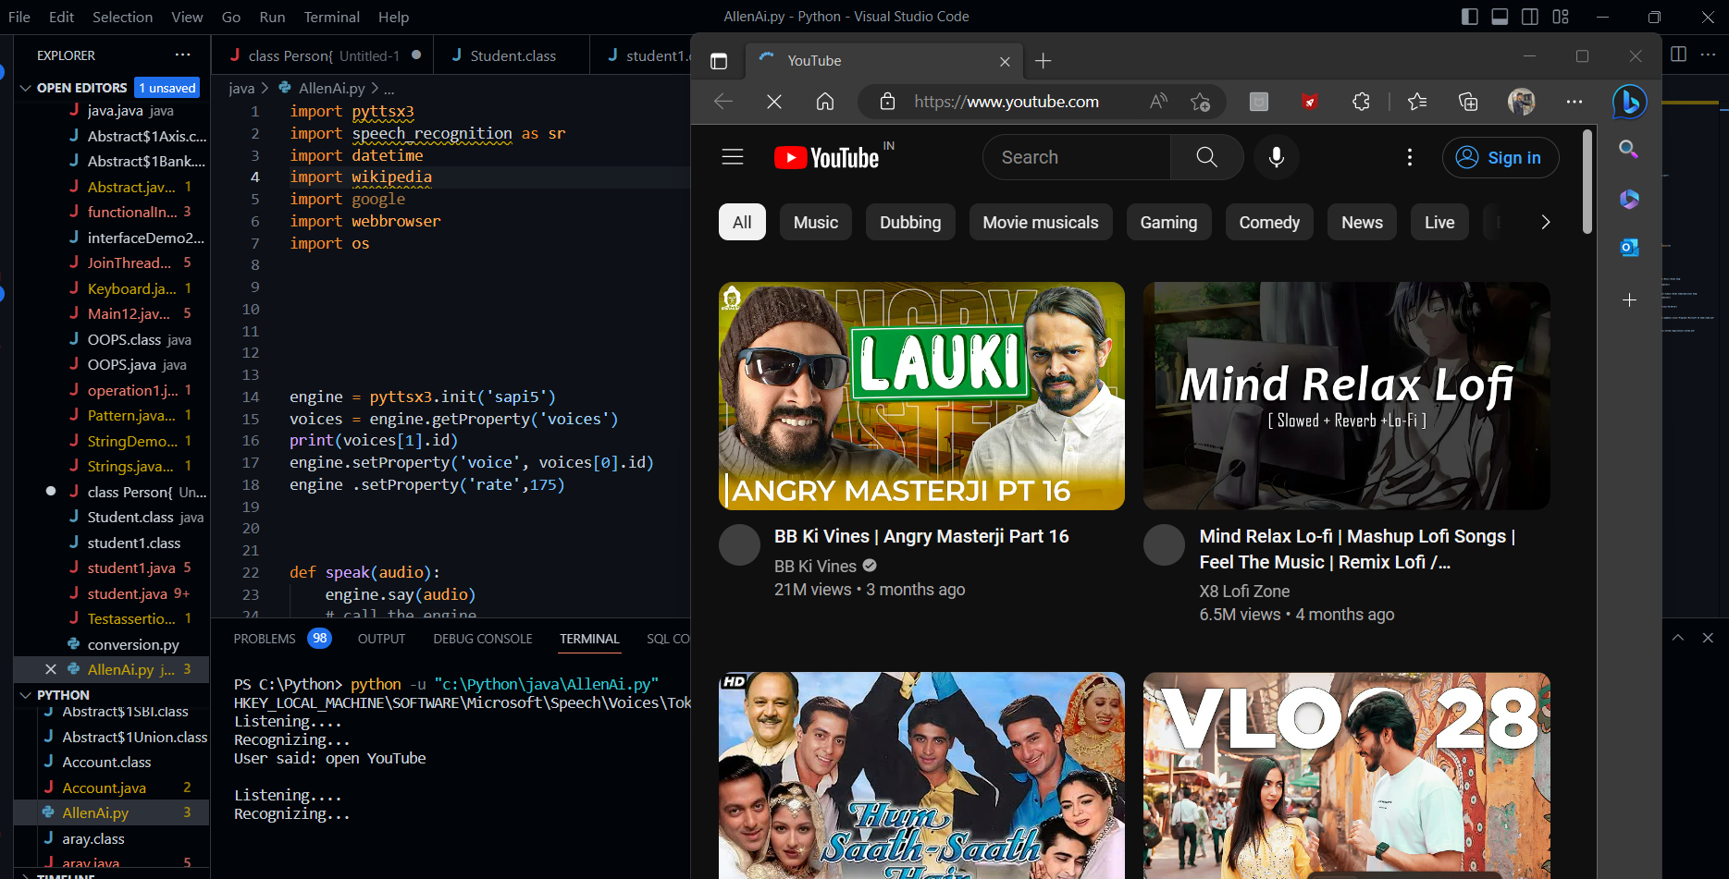

Opening Music

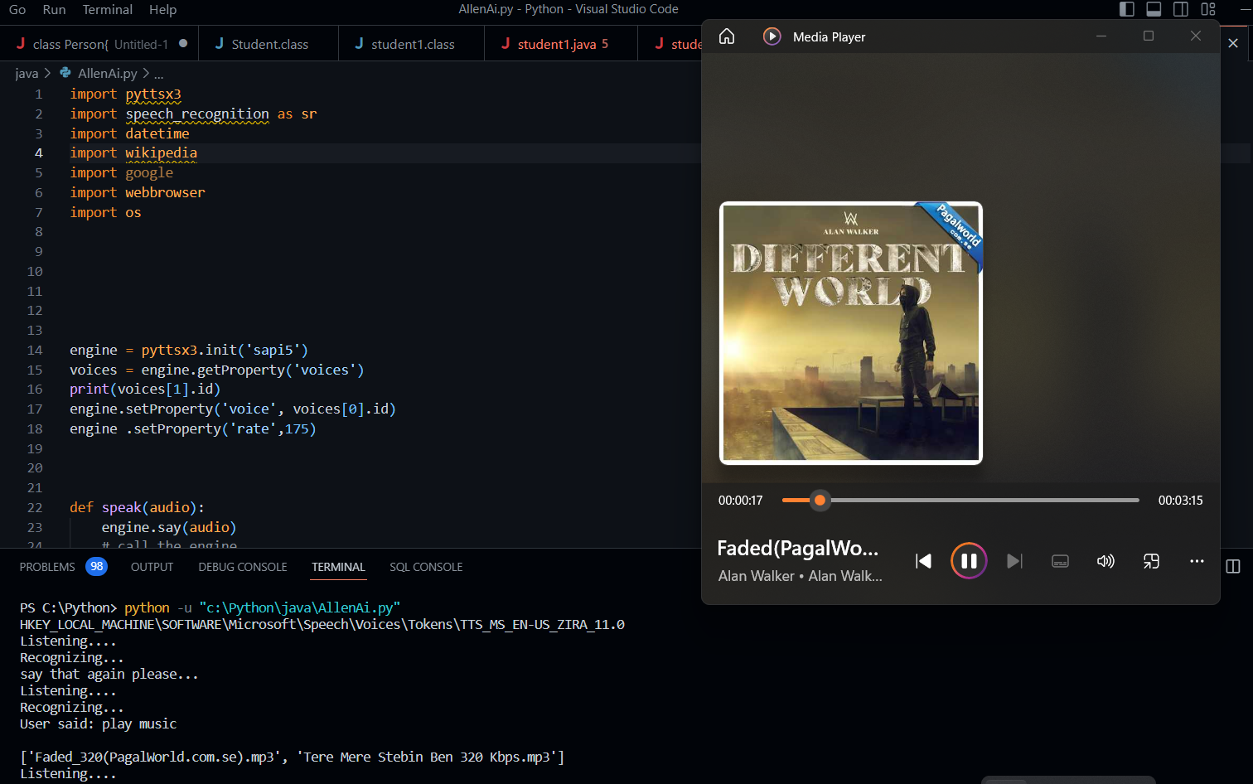

Chapter 7 Conclusion

7.1 Future scope

The voice recognition isn't perfect as such. One of disadvantages of this voice assistant is that users should be loud and clear while they are interacting with voice assistant because it may happen that if your voice is not clear your voice assistant may not be able to interpret you properly. In such cases voice recognition might be difficult. The system can be further developed to improve voice recognition, accuracy and response rate of the model.

7.2 Closure
Throughout the history of computing, user interfaces have become progressively natural to use. The screen and keyboard were one step in this direction. The mouse and graphical user interface.

REFERENCES

- https://www.geeksforgeeks.org/speech-recognition-in-python-using-google-speech-api/
2. https://www.ripublication.com/irph/ijert spl17/ijertv10n1spl 80.pdf 3.
3. https://www.irjet.net/archives/V9/11/IRJET-V91138.pdf/
4. https://data-flair.training/blogs/artificial-neural-networks-for-machine-learning/ 5. https://medium.com/swih/al-revolution-voice-assistants-their-smartness- c7afe2580e74
6. https://www.tutorialspoint.com/natural language processing/natural language/

